Dear Neighbors:
We hope that you are well and adjusting to our current circumstances. As you may remember you were sent a postcard in February inviting you to attend one of two meetings scheduled in the beginning of March 2020. Due to the Governor’s “shelter in place” orders, we were unable to host those previously scheduled meetings in person, as scheduled. We have been working with the City of Vista as to how we best keep you, our neighbors, in the loop in regard to our plans, and they have encouraged us to mail information directly to you and set-up an email dedicated specifically to your comments and feedback.
As we mentioned in the postcard, our Church is looking to move forward to complete our original plans that were presented to the City approximately 17 years ago. The United Methodist Church of Vista has been a mainstay in Vista and the surrounding area for well over 70 years and we are planning for at least 70 more. The proposed plan will provide additional office space, Sunday school classrooms, bathrooms, an updated fellowship hall and a fully equipped kitchen. After assessing the needs of our community and the partnerships we have with our outreach services, the completion of our Church will answer the ongoing needs of our area. We currently provide a meal one day a week to the economically underemployed, resulting in the service of 30-50 individuals weekly, hosted by approximate one dozen volunteers from our congregation. During these unprecedented times we have shifted our in-person ministry to offering an online worship and connections but we are in service collecting items to provide to our North County Food Bank, Interfaith Community Services and Vista Teen Outreach.
As we work through the pandemic, in addition to providing religious services and serving as a gathering place for our members, UMC Vista is also committed to using our facility to provide space for disaster relief and to provide emergency shelter for Vista residents. We are planning to work with our local Red Cross offices as well as receiving direction from the County and State as to how best we can be a resource in trying times, should the need ever arise.
Finally, our Church is committed to a person’s life from their birth until their final breath. Providing a final resting place where their family can quietly remember, honor, reflect and pray is an important part of what our faith provides. To answer that need we are also proposing the construction of a Columbarium for cremains.
We are providing a diagram of the floor plan, a rendition of the Columbarium and an elevation photo of the finished extension as well as a FAQ sheet which we hope will answer the majority of your questions. Should you have additional questions or wish to provide feedback, please contact the Church office at umcvista@umcvista.org. We will respond within 48 business hours.
Thank you in advance for your consideration.
In good faith,
Rev. Dr. Leigh Ann Shaw

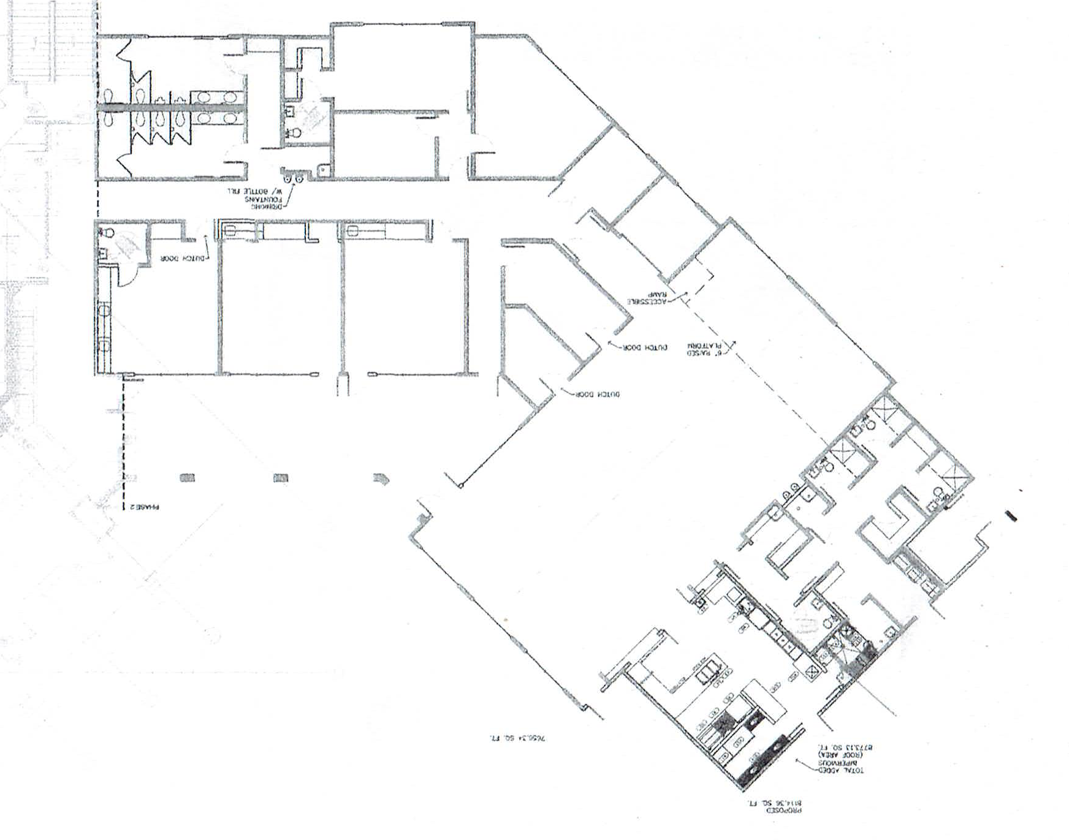
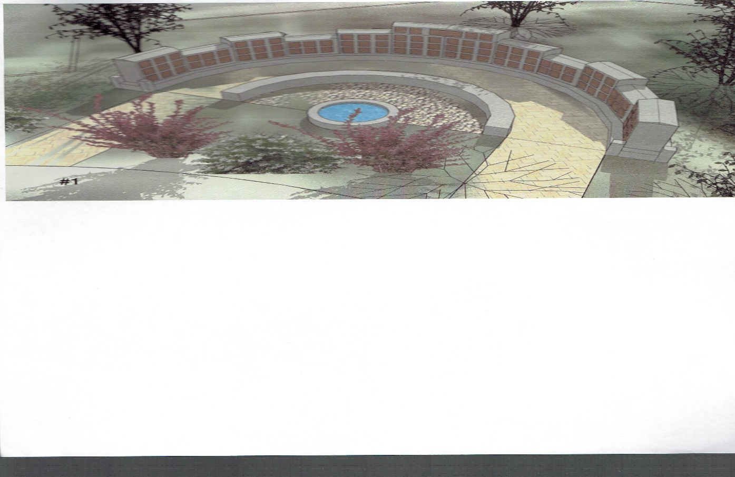
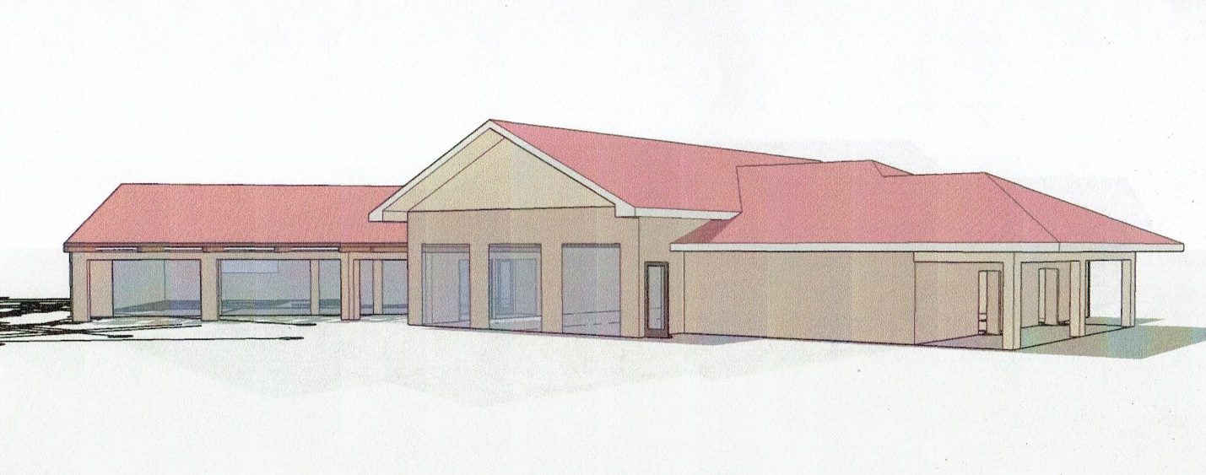

FAQ’S
- Will the roof line be higher than the existing roof on the current Church building?
NO

- Does the Church currently have a large enough “footprint” for this extension?
YES, since this was part of our original design the property was purchased accordingly.

- Will there be enough parking spaces to accommodate this extension?
YES, we have taken that into consideration and there will be sufficient parking. We do not envision parking spilling out into the neighborhood area.

- Will traffic be affected and would that be an impact to the surrounding businesses and Community?
NO, we are on the corner of Matagual Dr. and South Melrose Drive. To enter our existing parking lots, there are two entrances from Matagual and one from South Melrose Dr. The corner is controlled by a metered traffic light for those traveling north/south on Melrose Dr. or turning onto Matagual from either direction, so traffic impacts would not be a concern.

- What would the hours of construction be?
Typically, Monday – Friday from 8:00 a.m. – 3:00 p.m.

- Who are your Community Partners?
We work with a number of reputable and valuable organizations throughout North County. Some of our stand-out partners are Tri-City Hospital, Leap to Success, Scouts, Soroptimist Club of Vista, Vista Teen Outreach, Operation Hope-Vista, Casa de Amparo, Foundation for Senior Well Being, Interfaith Community Services, Solutions for Change, Survivors of Suicide Loss, Wounded Warrior Homes, Women’s Resource Center, North County Lifeline, Canine Companions just to name a few.

- Are you open to suggestions from the Community?
YES, we are always open to helpful suggestions. If you would like to arrange for an individual tour of the exterior areas that would be used please call to set up an appointment to do so. We would ask that the recommended distancing and mask be worn for your and our safety.

